**Project Design Phase-II**

**Technology Stack (Architecture & Stack)**

| Date | 15-10-2022 |
| --- | --- |
| Team ID | PNT2022TMID53089 |
| Project Name | Personal Expense Tracker |
| Maximum Marks | 4 Marks |

**Technical Architecture:**

The Deliverable shall include the architectural diagram as below and the information as per the table1 & table 2

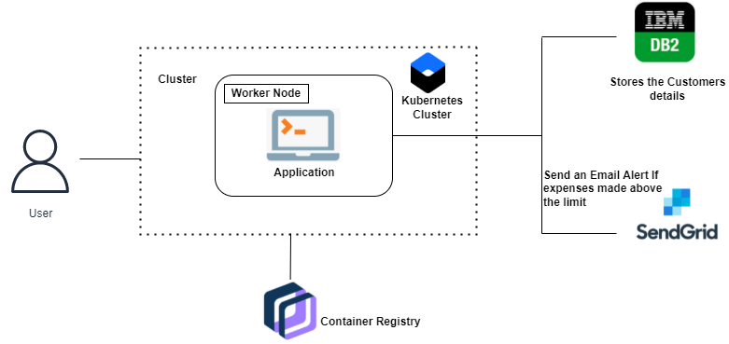

**Table-1: Components & Technologies:**

| **S.No** | **Component** | **Description** | **Technology** |
| --- | --- | --- | --- |
|  | User Interface | How the user interacts with application e.g.  Web UI, Mobile App, Chatbot etc. | HTML, CSS, JavaScript, Python Flask, etc. |
|  | User Login | User can able to login through their email account. | Python Flask |
|  | Application Logic 1 | Dashboard contains field like add income, add expense, view reports etc | Python flask |
|  | Graph Visualisation | Rendering plots and graphs based on the user  spending data | Seaborn, Matplotlib |
|  | Database | The income and expense data are stored in the MySQL database. | MySQL |
|  | Cloud Database | With the use of database service on cloud the user data are stored in a well secured manner | IBM DB2 |
|  | File Storage | IBM Block storage is used to store the financial data of the user. | IBM Block Storage |
|  | SendGrid | A cloud-based SMTP provider that allows you to  send email without having to maintain email  servers | SendGrid is used to trigger mail to user  emails when a particular condition is  met. |
|  | Infrastructure (Server / Cloud) | Application Deployment on Cloud | Cloud Foundry, Kubernetes, etc. |

**Table-2: Application Characteristics:**

| **S.No** | **Characteristics** | **Description** | **Technology** |
| --- | --- | --- | --- |
|  | Open-Source Frameworks | Python-based Flask is a microweb framework which is used to implement this application. | Python Flask Framework |
|  | Security Implementations | This application provides high security to the user financial data. It can be done by using the container in IBM cloud | Contains Registry, Kubernetes cluster |
|  | Scalable Architecture | Expense tracker is a lifetime access supplication.  Its demand will increase when the user’s income are high. | Container Registry, Kubernetes cluster |
|  | Availability | This application will be available to user at any point of time | Container Registry, Kubernetes cluster |
|  | Performance | The performance will be high because the traffic will be less in the application | Kubernetes cluster |